FOR IMMEDIATE RELEASE

For further information, please contact:

Jennifer Bishop, Marketing & Communications Manager
Dynapac North America
Telephone: 210-771-4461
Email: Jennifer.bishop@dynapac.com

Fort Mill, S.C. – October 21, 2019 – Dynapac North America LLC, a leading manufacturer of high tech rollers for asphalt and soil applications, pavers and feeders is pleased to welcome Jason Ammon back to the Dynapac team as Vice President, Product Support & Operations.
Ammon is based in the Fort Mill, SC office reporting to Brian Bieller, President of Dynapac North America.
“Jason’s experience with the inter-workings of OEM aftermarket and operations will be a tremendous asset to Dynapac, our partners and end-users,” said Bieller.
Ammon began his career in the construction equipment industry with Dynapac in 2007 at the Schertz, TX operation as the Aftermarket Product Support Specialist. He has since taken on roles in multiple facets of responsibility within the construction equipment business leading several teams in the area of aftermarket and customer support.
“The Dynapac brand and foundation has been firmly reestablished, and I look forward to helping build the next level of support for our customers,” Ammon said. “It is an exciting time and I am very glad to be back at Dynapac.”
Ammon holds a degree in Management from Southwest Texas State.

Dynapac is a leading supplier of high-tech soil and asphalt rollers, pavers and milling equipment, committed to strengthening customer performance. Dynapac is represented worldwide via its own regional sales and service offices, and also cooperates with an extensive professional distribution network. Headquartered in Wardenburg, Germany, Dynapac has production facilities in Europe, South America, and Asia. Dynapac is part of the FAYAT Group. Dynapac North America customer support and distribution is located in Fort Mill, SC. www.dynapac.us.

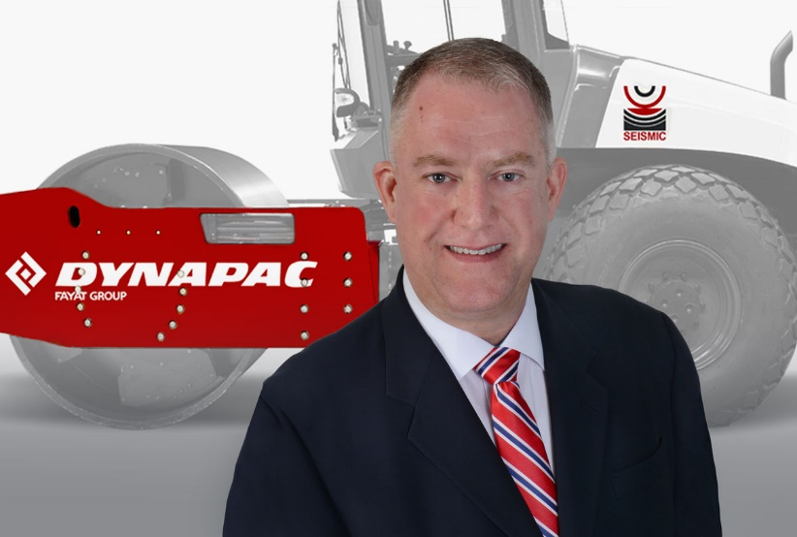
Jason Ammon, Dynapac Vice President – Product Support and Operations

